C16 Naming of organic compounds
Name: ____________________ Class: ____________________ Due date:
1. Which structure is correctly named? （ ）
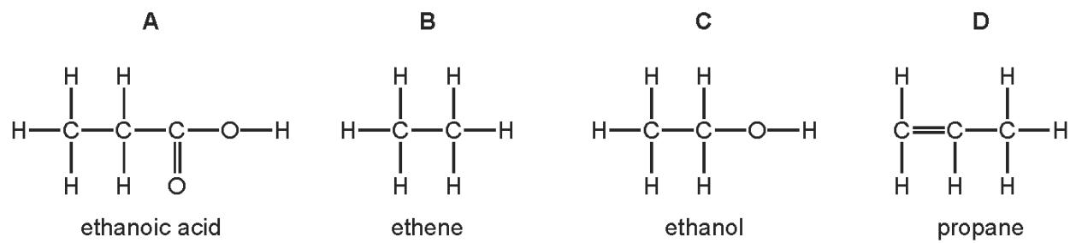

3. Three types of organic compound are alkanes, alkenes and alcohols.
Which structure does not belong to any of these three types of compound? （ ）
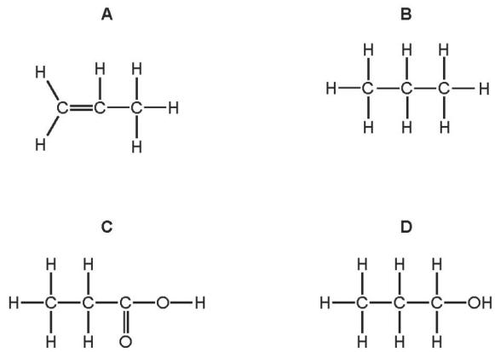

6. Which molecular structure shows hexene? （ ）
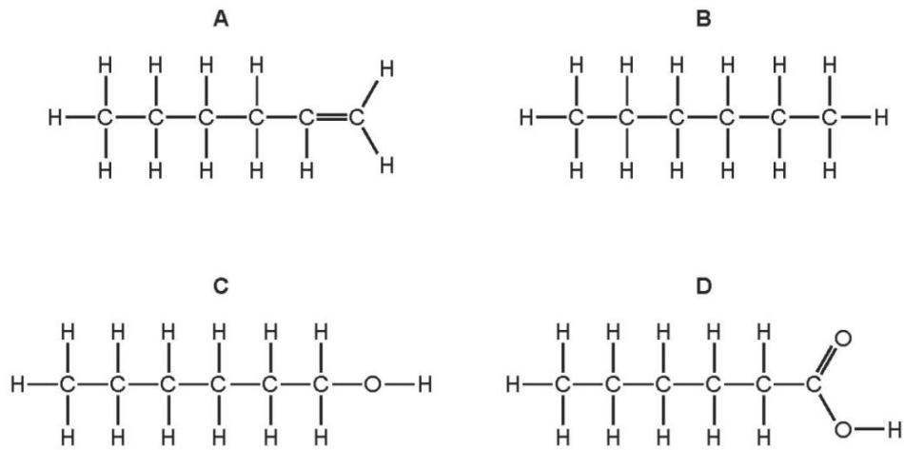

9. Which statement about the names of organic compounds is correct? （ ）
A Compounds containing $C=C$ double bonds are alkanes.
B The compound of formula ${CH}_{3}{CO}_{2}H$ is methanoic acid.
C The compound of formula $C_{2}H_{4}$ is ethane.
D The compound of formula $C_{2}H_{5}OH$ is an alcohol.

8. The diagram shows the structure of a simple hydrocarbon and the products of two of its reactions.
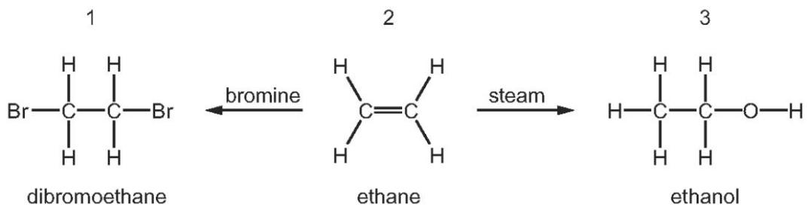
Which structures are named correctly? （ ）
 | structure
 | 1 | 2 | 3
A | ✓ | ✓ | ×
B | ✓ | × | ✓
C | × | ✓ | ✓
D | × | ✓ | ×

9. The structure of an alkene and the structure of an ester are shown.
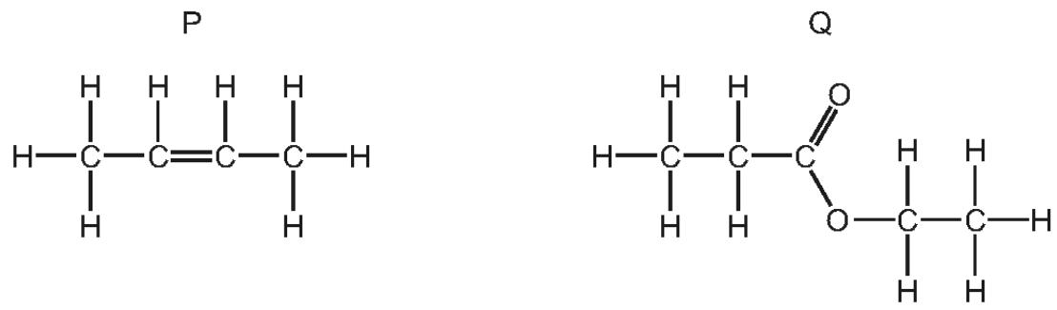
What are the names of P and Q? （ ）
 | P | Q
A | but⁻¹-ene | ethyl propanoate
B | but⁻¹-ene | propyl ethanoate
C | but⁻²-ene | ethyl propanoate
D | but⁻²-ene | propyl ethanoate

10. The structures of six organic compounds are shown.
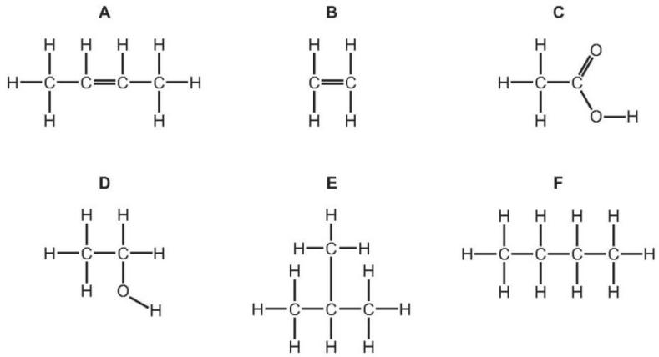
Give the name of F.
..................................................................................................................................[1]
Identify two of the compounds that are members of the same homologous series.
Give the general formula of this homologous series.
compounds ........................................................................................................
general formula ..........................................................................................................[2]

